- Heatmapping

  - Liner heatmap
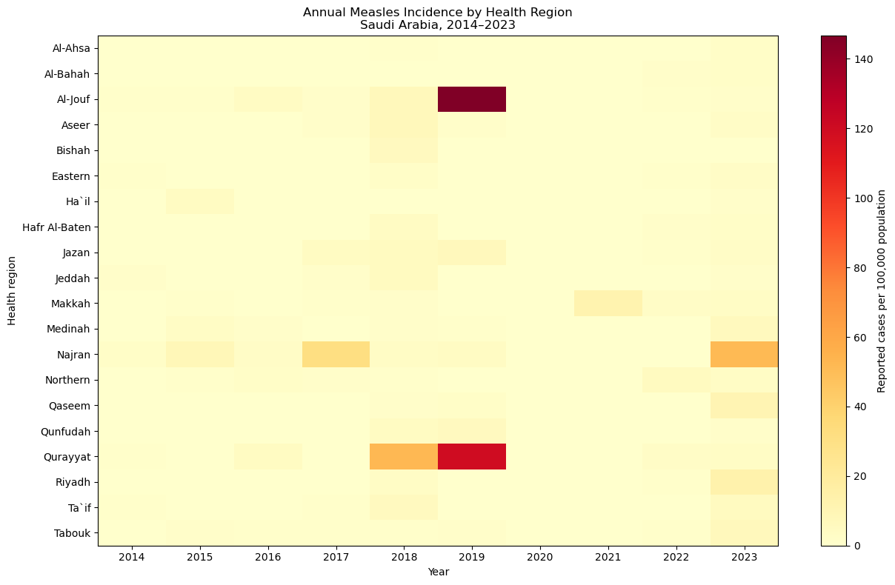
The map is pale and lacks contrast, making it difficult to distinguish meaningful differences among regions with lower incidence rates. Therefore, we use a logarithmic color transformation log1p, defined as: $y=\ln{(1+x)}$.

  - Log-transformed heatmap
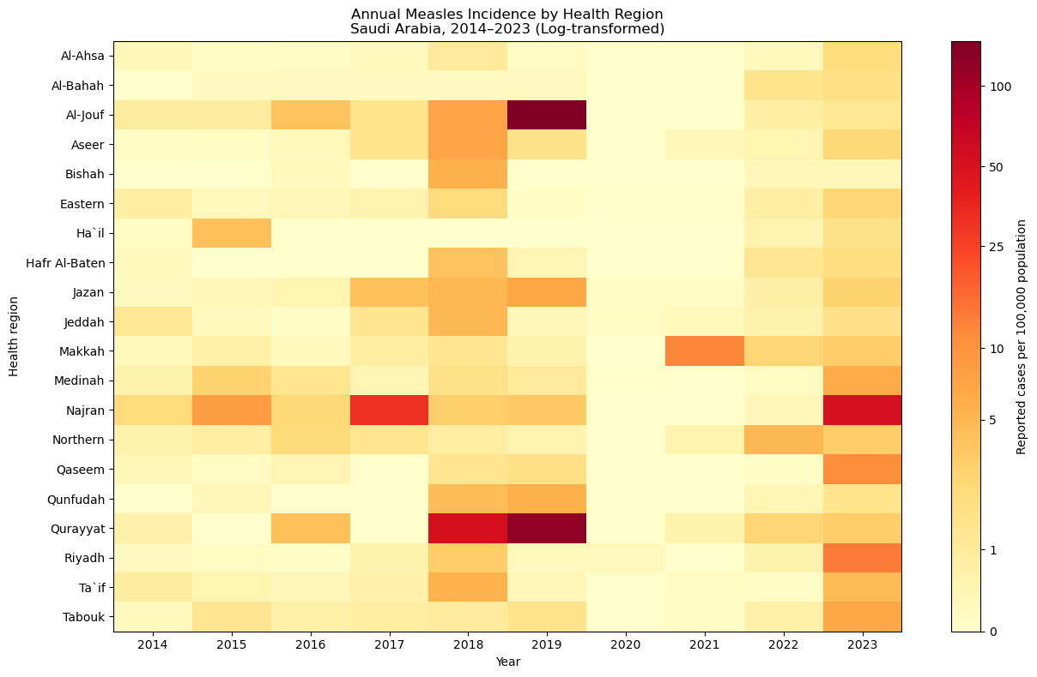

- Observed-to-expected (O/E) ratio
$${O/E}_{r}=\frac{O_{r}}{E_{r}}$$
Where:
$O_{r}$: Total observed cases in region $r$ over 2014-2023
$E_{r}$: Total expected cases, calculated using the corresponding national annual incidence rates and that region's annual populations.
$$E_{r}=\sum_{t=2014}^{2023}{(\frac{C_{t}}{P_{t}}×P_{r,t})}$$
$C_{t}$ is the national case count, $P_{t}$ is the national population, and $P_{r,t}$ is the regional population in year $t$.

Health region | Observed cases | Expected cases | Total population exposure | O/E ratio | 95% CI lower (source) | 95% CI upper (source)
Qurayyat | 317 | 33.365 | 1,763,900 | 9.501 | 8.484 | 10.607
Al-Jouf | 567 | 67.631 | 3,551,052 | 8.384 | 7.708 | 9.103
Najran | 603 | 108.627 | 5,906,522 | 5.551 | 5.117 | 6.012
Makkah | 545 | 456.722 | 23,919,901 | 1.193 | 1.095 | 1.298
Jazan | 322 | 277.746 | 15,528,022 | 1.159 | 1.036 | 1.293
Riyadh | 1600 | 1,550.511 | 83,417,447 | 1.032 | 0.982 | 1.084
Northern | 55 | 68.465 | 3,722,828 | 0.803 | 0.605 | 1.046
Qaseem | 204 | 256.654 | 14,181,605 | 0.795 | 0.690 | 0.912
Aseer | 253 | 328.866 | 18,168,190 | 0.769 | 0.677 | 0.870
Medinah | 300 | 395.170 | 21,473,746 | 0.759 | 0.676 | 0.850
Ta`if | 160 | 225.420 | 12,735,124 | 0.710 | 0.604 | 0.829
Qunfudah | 38 | 54.343 | 3,056,697 | 0.699 | 0.495 | 0.960
Tabouk | 116 | 166.649 | 9,147,824 | 0.696 | 0.575 | 0.835
Jeddah | 489 | 805.627 | 45,118,915 | 0.607 | 0.554 | 0.663
Hafr Al-Baten | 36 | 84.397 | 4,563,071 | 0.427 | 0.299 | 0.591
Eastern | 254 | 622.873 | 33,105,189 | 0.408 | 0.359 | 0.461
Bishah | 25 | 65.910 | 3,775,568 | 0.379 | 0.245 | 0.560
Ha`il | 46 | 133.105 | 7,143,656 | 0.346 | 0.253 | 0.461
Al-Ahsa | 51 | 217.426 | 12,132,673 | 0.235 | 0.175 | 0.308
Al-Bahah | 16 | 77.494 | 4,531,270 | 0.206 | 0.118 | 0.335
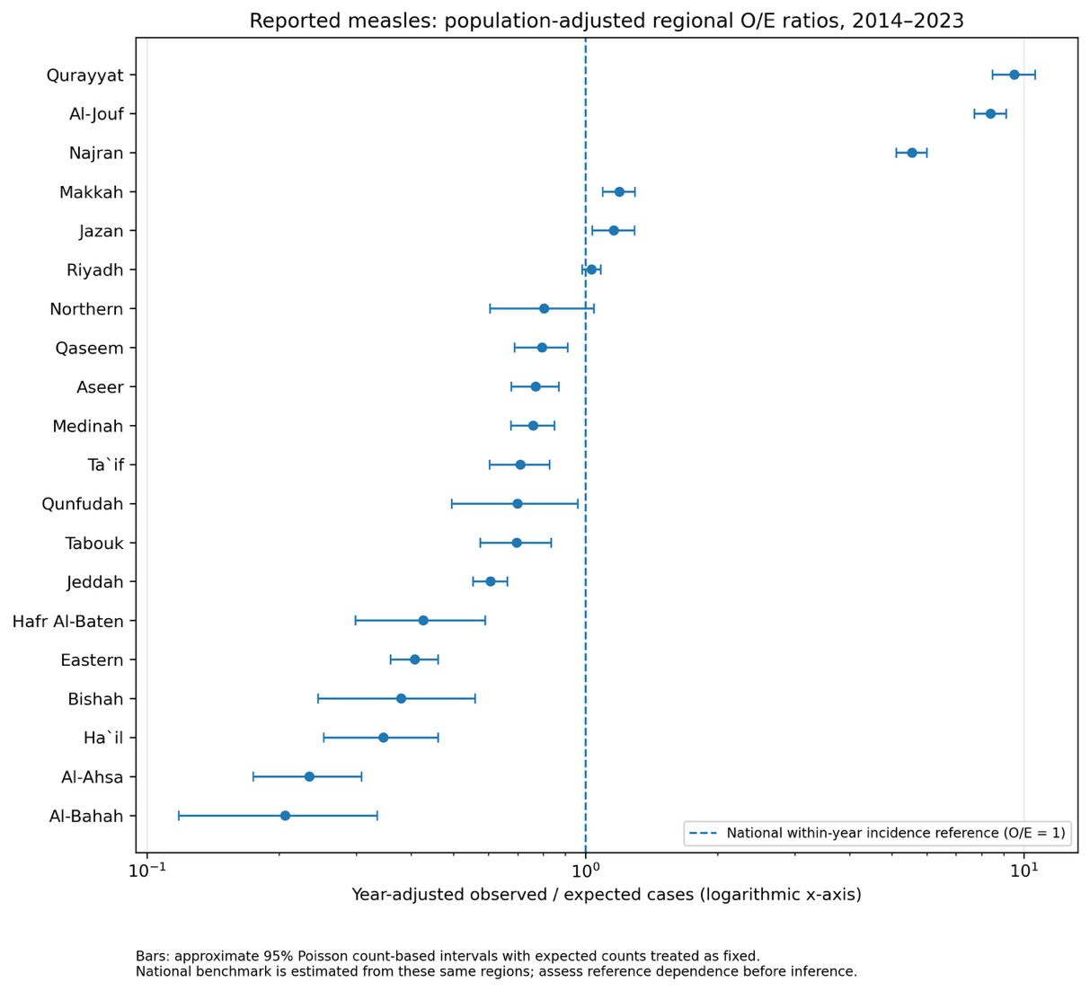

- Simulation-based O/E reference visualization
To further evaluate regional differences in reported measles incidence, we used a simulation-based approach to compare the observed-to-expected (O/E) ratios with a population-adjusted reference distribution. This approach helps distinguish the observed differences between regions from the variation that might occur simply by chance under an assumption of equal incidence. Using a multinomial model, we generated 20,000 simulated datasets in which the annual national number of measles cases was kept constant, while cases were randomly distributed among the 20 health regions according to their population shares. For each simulation, regional cases were summed across 2014–2023 and O/E ratios were recalculated. The 2.5th and 97.5th percentiles of these simulated ratios were used to construct 95% null reference intervals, which were visualized alongside the actual observed ratios. These intervals represent expected variation under the specified simulation model rather than confidence intervals for the observed estimates.
Health region | 95% null lower | 95% null upper | Observed O/E ratio
Al-Ahsa | 0.869260 | 1.131418 | 0.234562
Al-Bahah | 0.787161 | 1.225906 | 0.206468
Al-Jouf | 0.768884 | 1.242043 | 8.383791
Aseer | 0.897021 | 1.103792 | 0.769310
Bishah | 0.773783 | 1.244121 | 0.379305
Eastern | 0.926352 | 1.074055 | 0.407788
Ha`il | 0.833925 | 1.172003 | 0.345591
Hafr Al-Baten | 0.793866 | 1.220421 | 0.426555
Jazan | 0.885703 | 1.116129 | 1.159334
Jeddah | 0.935917 | 1.066250 | 0.606981
Makkah | 0.913028 | 1.088189 | 1.193286
Medinah | 0.905940 | 1.095732 | 0.759168
Najran | 0.819321 | 1.187555 | 5.551127
Northern | 0.774121 | 1.241515 | 0.803333
Qaseem | 0.880563 | 1.118335 | 0.794845
Qunfudah | 0.736065 | 1.269713 | 0.699262
Qurayyat | 0.689346 | 1.348721 | 9.500987
Riyadh | 0.957104 | 1.043527 | 1.031918
Ta`if | 0.873923 | 1.131220 | 0.709785
Tabouk | 0.852090 | 1.152122 | 0.696074
Note: The 95% null reference bounds were generated from 20,000 population-proportional multinomial simulations. These are not confidence intervals for the observed O/E ratios. Values are rounded to three decimals.
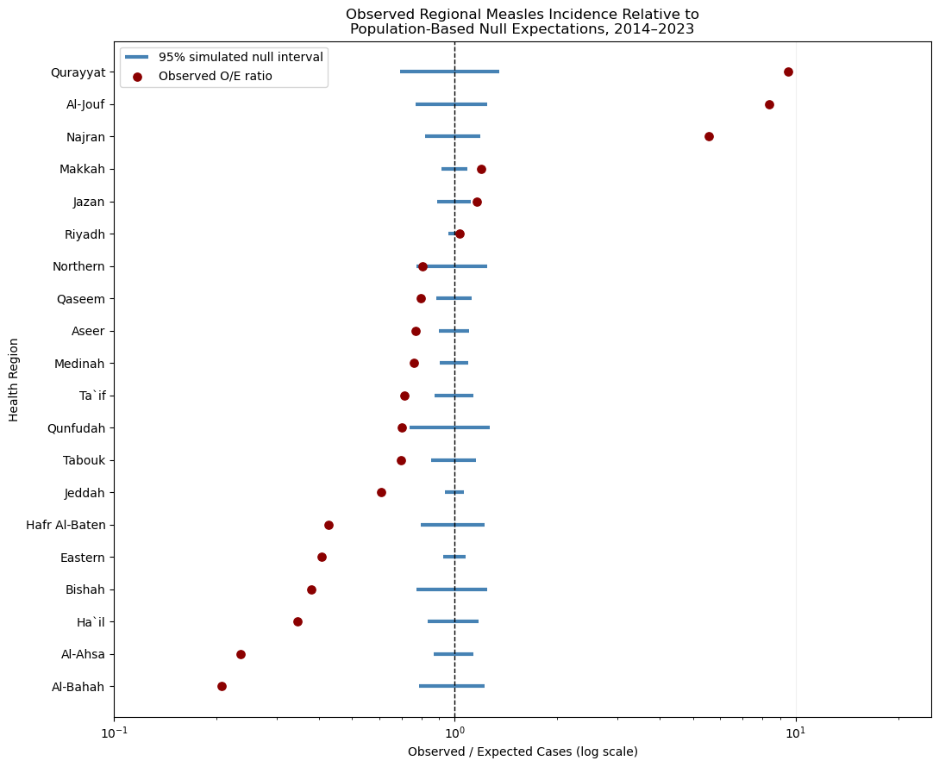

- Simultaneous Simulation-based reference intervals
Instead of examining each region independently, we calculate the larges standardized depature from expected incidence across all regions in each simulated dataset. This addresses multiplicity under our specified simulation model.
$$T_{s}=\begin{matrix}max \\ r\end{matrix}\left|\frac{O_{r}^{\left(s\right)}-E_{r}}{σ_{r}}\right|$$
Were:
$O_{r}^{\left(s\right)}:$ Simulated cases in region $r$, simulation $s$.
$E_{r}:$ Expected cases in that region
$σ_{r}:$ Standard deviation under our multinomial reference model
$T_{s}:$ Largest stander deviation across all 20 regions in one simulation

Health region | Observed cases | Expected cases | O/E ratio | Null SD | Simultaneous lower 95 | Simultaneous upper 95
Qurayyat | 317 | 33,36495 | 9,500987 | 5,760056 | 0,476706 | 1,523294
Al-Jouf | 567 | 67,63051 | 8,383791 | 8,176907 | 0,633515 | 1,366485
Najran | 603 | 108,6266 | 5,551127 | 10,32756 | 0,711815 | 1,288185
Makkah | 545 | 456,7219 | 1,193286 | 20,53587 | 0,863708 | 1,136292
Jazan | 322 | 277,7456 | 1,159334 | 16,27424 | 0,822392 | 1,177608
Riyadh | 1600 | 1550,511 | 1,031918 | 33,90162 | 0,933724 | 1,066276
Northern | 55 | 68,46475 | 0,803333 | 8,226961 | 0,635765 | 1,364235
Qaseem | 204 | 256,6539 | 0,794845 | 15,67363 | 0,814889 | 1,185111
Aseer | 253 | 328,8662 | 0,76931 | 17,6301 | 0,837503 | 1,162497
Medinah | 300 | 395,1696 | 0,759168 | 19,21272 | 0,852628 | 1,147372
Ta`if | 160 | 225,4204 | 0,709785 | 14,72748 | 0,801964 | 1,198036
Qunfudah | 38 | 54,343 | 0,699262 | 7,338162 | 0,590689 | 1,409311
Tabouk | 116 | 166,649 | 0,696074 | 12,72861 | 0,76848 | 1,23152
Jeddah | 489 | 805,6269 | 0,606981 | 26,39851 | 0,900676 | 1,099324
Hafr Al-Baten | 36 | 84,39708 | 0,426555 | 9,121865 | 0,672383 | 1,327617
Eastern | 254 | 622,8733 | 0,407788 | 23,62186 | 0,885046 | 1,114954
Bishah | 25 | 65,90998 | 0,379305 | 8,073257 | 0,628715 | 1,371285
Ha`il | 46 | 133,1055 | 0,345591 | 11,40819 | 0,740205 | 1,259795
Al-Ahsa | 51 | 217,4263 | 0,234562 | 14,47504 | 0,798202 | 1,201798
Al-Bahah | 16 | 77,49369 | 0,206468 | 8,744595 | 0,657955 | 1,342045

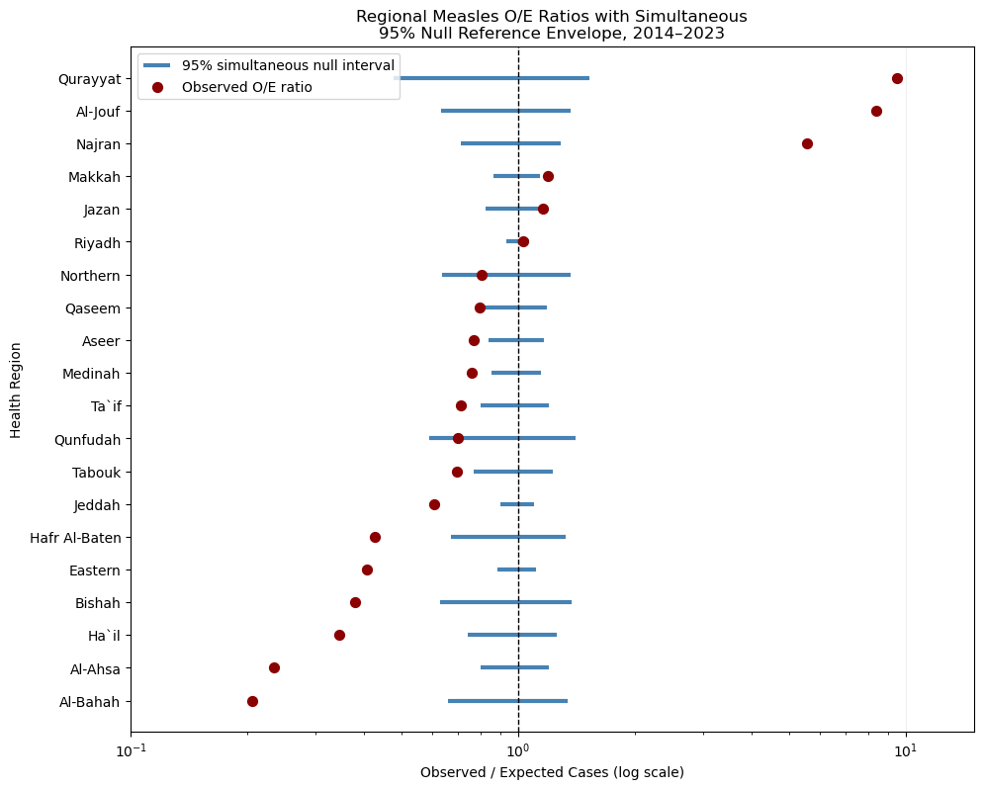
Empirical simultaneous coverage: 0.950
Minimum lower O/E limit: 0.47670599335743474
Independent simultaneous coverage: 0.950
Minimum SD ratio: 0.989
Maximum SD ratio: 1.01
SDs agree within 5%: True
Simulations at least as concentrated: 0
Monte Carlo upper-tail p-value: 0.000050

In the following figure, the population-weighted Lorenz curve of reported measles cases across 20 Saudi health regions, 2014–2023. Regions were ranked by average annual incidence, and cumulative shares of population exposure and reported cases were plotted. The dashed diagonal indicates proportional equality, while the shaded area represents geographic concentration. The observed Gini-type concentration index was 0.369.

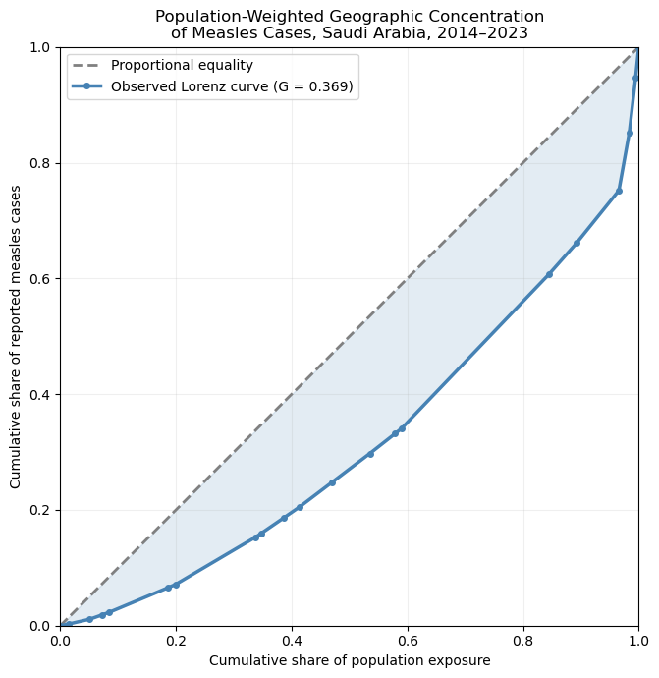

- Population-weighted geographic concentration
Regional measles cases and annual population estimates were aggregated over 2014–2023 to assess geographic concentration. Health regions were ranked by their average annual incidence rates, and cumulative population and case shares were used to construct a population-weighted Lorenz curve. Geographic concentration was summarized using a Gini-type index, calculated from the area under the curve. To provide a statistical reference, 20,000 multinomial simulations were performed, preserving annual national case totals while allocating cases according to regional population shares. The observed concentration index was 0.3687, compared with a simulated mean of 0.0309 and a 95% null reference interval of 0.0209–0.0419. These comparisons describe geographic concentration relative to the specified null model without establishing its underlying causes.
This is a useful addition because or previous O/E analysis compares individual regions against the national reference. Here we use a Lorenz curve wich provides a single visual summary how unevenly reported measles cases are distributed across the 20 health regions relative to their populations.

Health region | Total cases | Population exposure | Incidence per 100k | Population share | Case share
Al-Bahah | 16 | 4531270 | 0,353102 | 0,013860 | 0,002668
Al-Ahsa | 51 | 12132673 | 0,420353 | 0,037109 | 0,008504
Ha`il | 46 | 7143656 | 0,643928 | 0,021850 | 0,007671
Bishah | 25 | 3775568 | 0,662152 | 0,011548 | 0,004169
Eastern | 254 | 33105189 | 0,767251 | 0,101257 | 0,042355
Hafr Al-Baten | 36 | 4563071 | 0,788942 | 0,013957 | 0,006003
Jeddah | 489 | 45118915 | 1,083803 | 0,138002 | 0,081541
Qunfudah | 38 | 3056697 | 1,243172 | 0,009349 | 0,006337
Ta`if | 160 | 12735124 | 1,256368 | 0,038952 | 0,026680
Tabouk | 116 | 9147824 | 1,268061 | 0,027980 | 0,019343
Aseer | 253 | 18168190 | 1,392544 | 0,055570 | 0,042188
Medinah | 300 | 21473746 | 1,397055 | 0,065680 | 0,050025
Qaseem | 204 | 14181605 | 1,438483 | 0,043376 | 0,034017
Northern | 55 | 3722828 | 1,477372 | 0,011387 | 0,009171
Riyadh | 1600 | 83417447 | 1,918064 | 0,255144 | 0,266800
Jazan | 322 | 15528022 | 2,073670 | 0,047495 | 0,053694
Makkah | 545 | 23919901 | 2,278438 | 0,073162 | 0,090879
Najran | 603 | 5906522 | 10,209054 | 0,018066 | 0,100550
Al-Jouf | 567 | 3551052 | 15,967099 | 0,010861 | 0,094547
Qurayyat | 317 | 1763900 | 17,971540 | 0,005395 | 0,052860

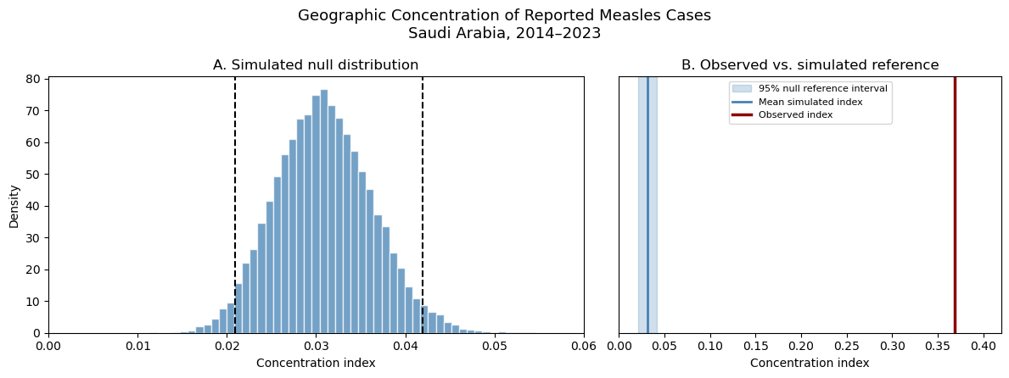

- Regional Peak-Year Concentration
To further characterize temporal variation in reported measles cases, we calculated the proportion of each health region's total cases that occurred during its highest-case year. This was obtained by dividing the number of cases reported in the peak year by the region's total reported cases during 2014–2023 and multiplying by 100. The resulting percentage provides a simple measure of whether reported cases were concentrated in a single year or distributed more evenly across the study period. This descriptive measure does not require statistical modeling and was visualized using a horizontal bar chart to facilitate comparison between regions.

Health region | Peak year | Peak year cases | Total cases | Peak year share percentage
Al-Jouf | 2019 | 510 | 567 | 89,95%
Bishah | 2018 | 22 | 25 | 88,00%
Riyadh | 2023 | 1157 | 1600 | 72,31%
Qaseem | 2023 | 144 | 204 | 70,59%
Qurayyat | 2019 | 207 | 317 | 65,30%
Ha`il | 2015 | 29 | 46 | 63,04%
Makkah | 2021 | 297 | 545 | 54,50%
Aseer | 2018 | 130 | 253 | 51,38%
Tabouk | 2023 | 59 | 116 | 50,86%
Najran | 2023 | 305 | 603 | 50,58%
Hafr Al-Baten | 2018 | 18 | 36 | 50,00%
Qunfudah | 2019 | 18 | 38 | 47,37%
Jeddah | 2018 | 231 | 489 | 47,24%
Al-Ahsa | 2023 | 23 | 51 | 45,10%
Ta`if | 2018 | 72 | 160 | 45,00%
Medinah | 2023 | 131 | 300 | 43,67%
Al-Bahah | 2023 | 6 | 16 | 37,50%
Eastern | 2023 | 92 | 254 | 36,22%
Jazan | 2019 | 109 | 322 | 33,85%
Northern | 2022 | 18 | 55 | 32,73%
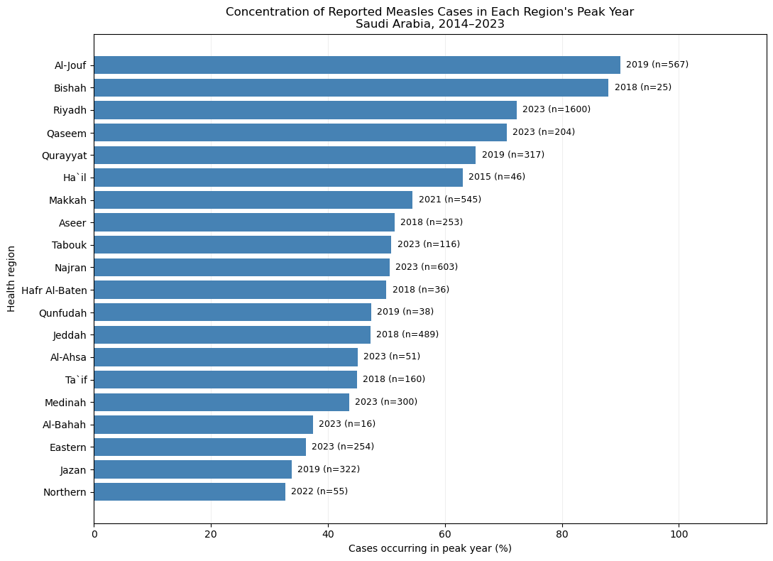

- Regional Annual Incidence Trajectories
To visualize changes in reported measles incidence across the 20 health regions during 2014–2023, annual incidence rates were displayed using small-multiple line plots. Two versions were generated: one with a common vertical-axis scale to allow direct comparison of incidence magnitudes between regions, and another with independent vertical-axis scales to improve the visibility of temporal patterns within individual regions. Both used the same calendar-year axis, without applying smoothing or statistical modeling.
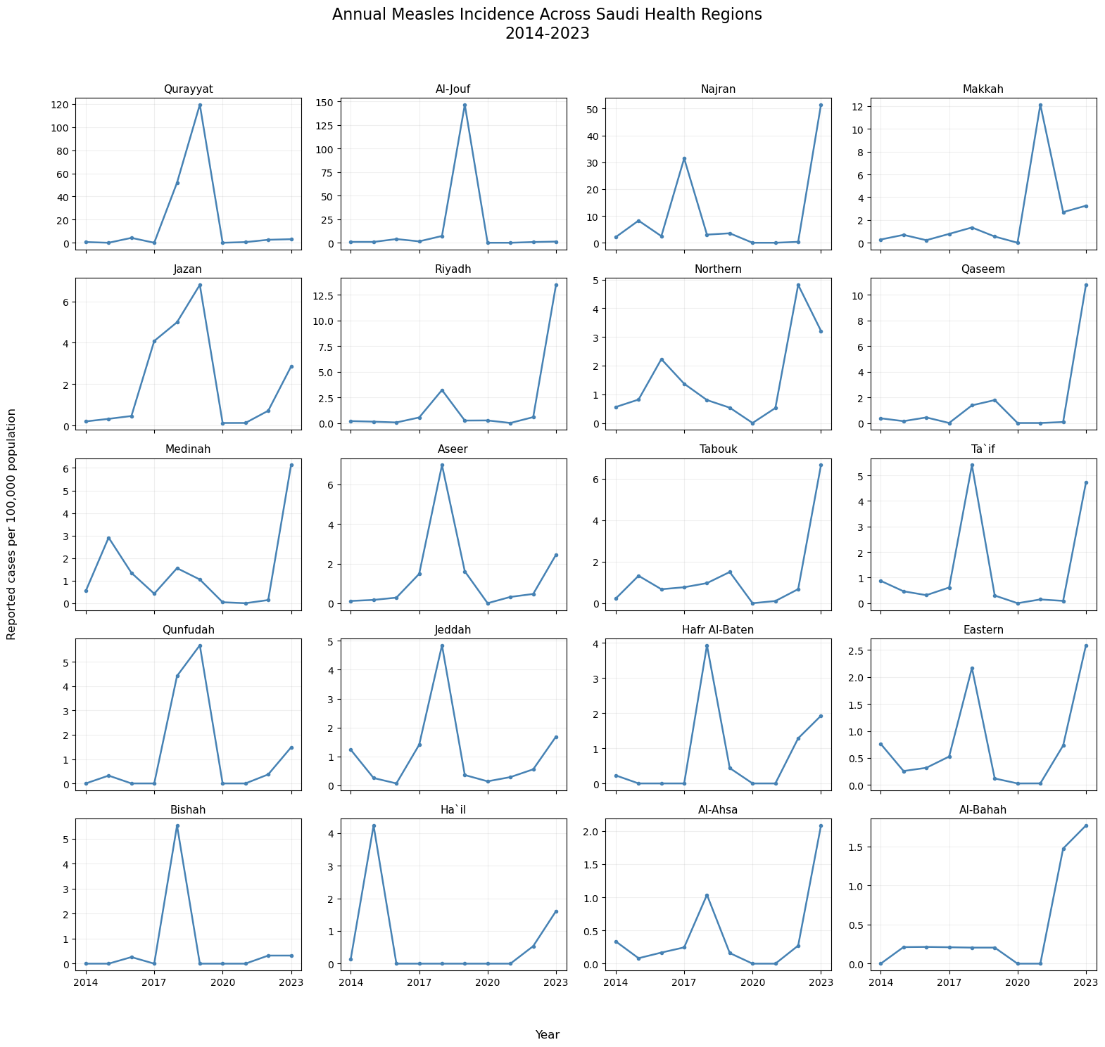

- Geospatial Visualization
  - Geospatial Visualization of Regional Measles Incidence
To visualize the geographic distribution of reported measles incidence in Saudi Arabia during 2014–2023, a choropleth map was constructed using the 20 health regions included in the surveillance dataset. Governorate-level geographic polygons were provisionally grouped according to the Ministry of Health health-region classifications and joined to the corresponding regional surveillance data. Average annual incidence rates were calculated using the total reported cases divided by the sum of annual population estimates over the study period, multiplied by 100,000.

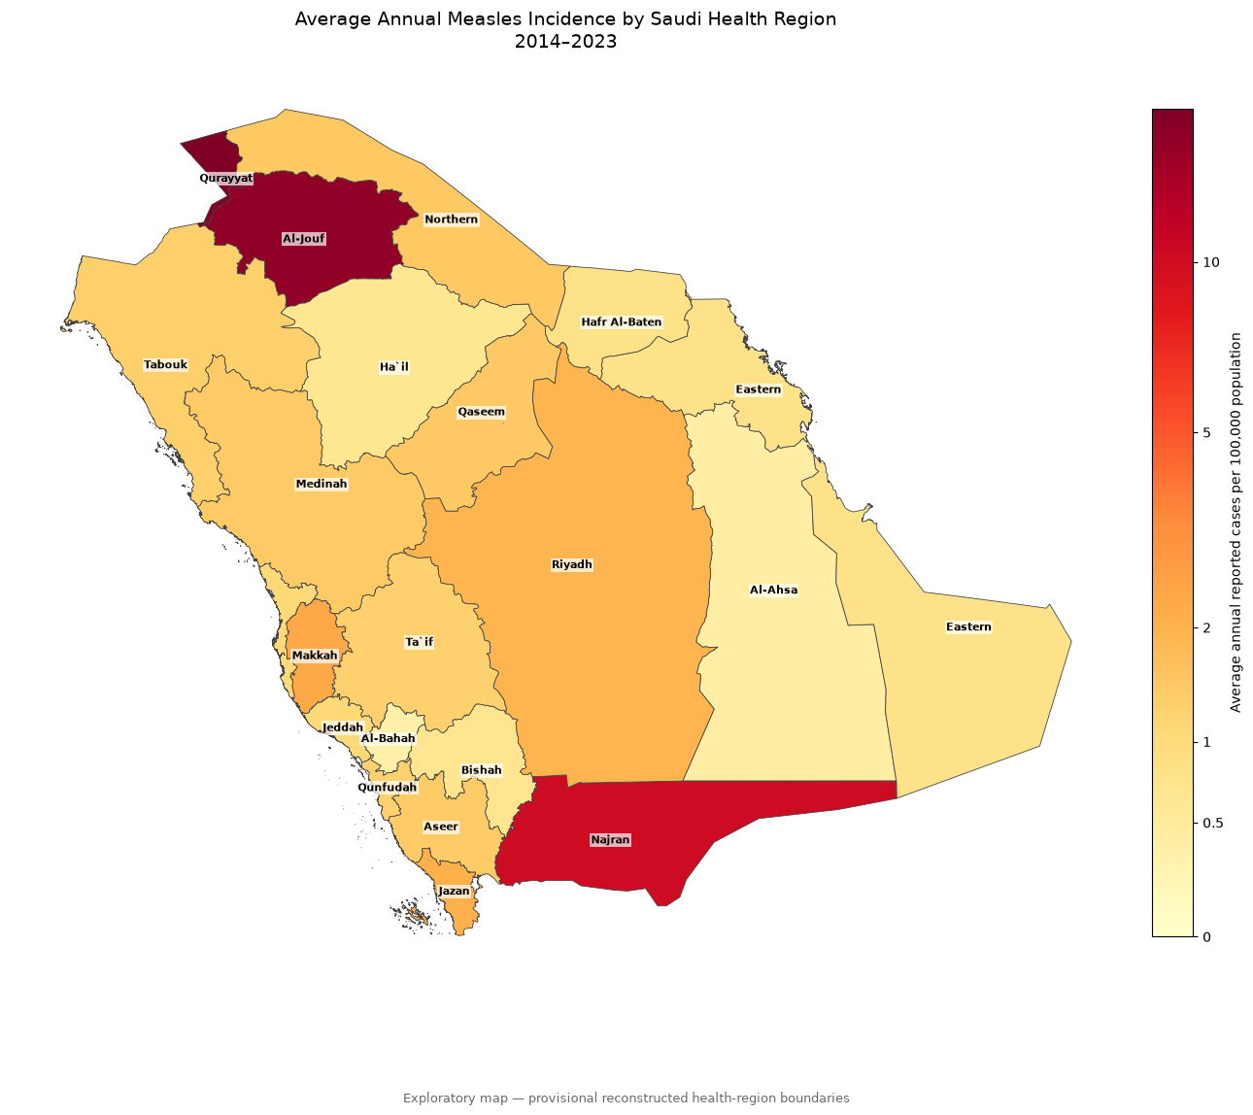
  - Geospatial Visualization of Regional Measles Incidence
To examine temporal changes in the geographic distribution of reported measles cases, annual incidence rates for the 20 Saudi health regions were visualized using a series of ten choropleth maps covering 2014–2023. Each region was assigned its corresponding annual incidence rate per 100,000 population. A consistent logarithmically transformed color scale was applied across all years to allow direct comparison of incidence magnitudes while improving the visibility of regions with lower incidence rates. The color legend displayed the original, untransformed incidence values.

These maps provide a descriptive representation of how reported measles incidence varied geographically over the study period without applying spatial interpolation or statistical modeling. The geographic boundaries remain provisional reconstructions based on governorate-level polygons and should not be interpreted as independently verified official Ministry of Health health-region boundaries.
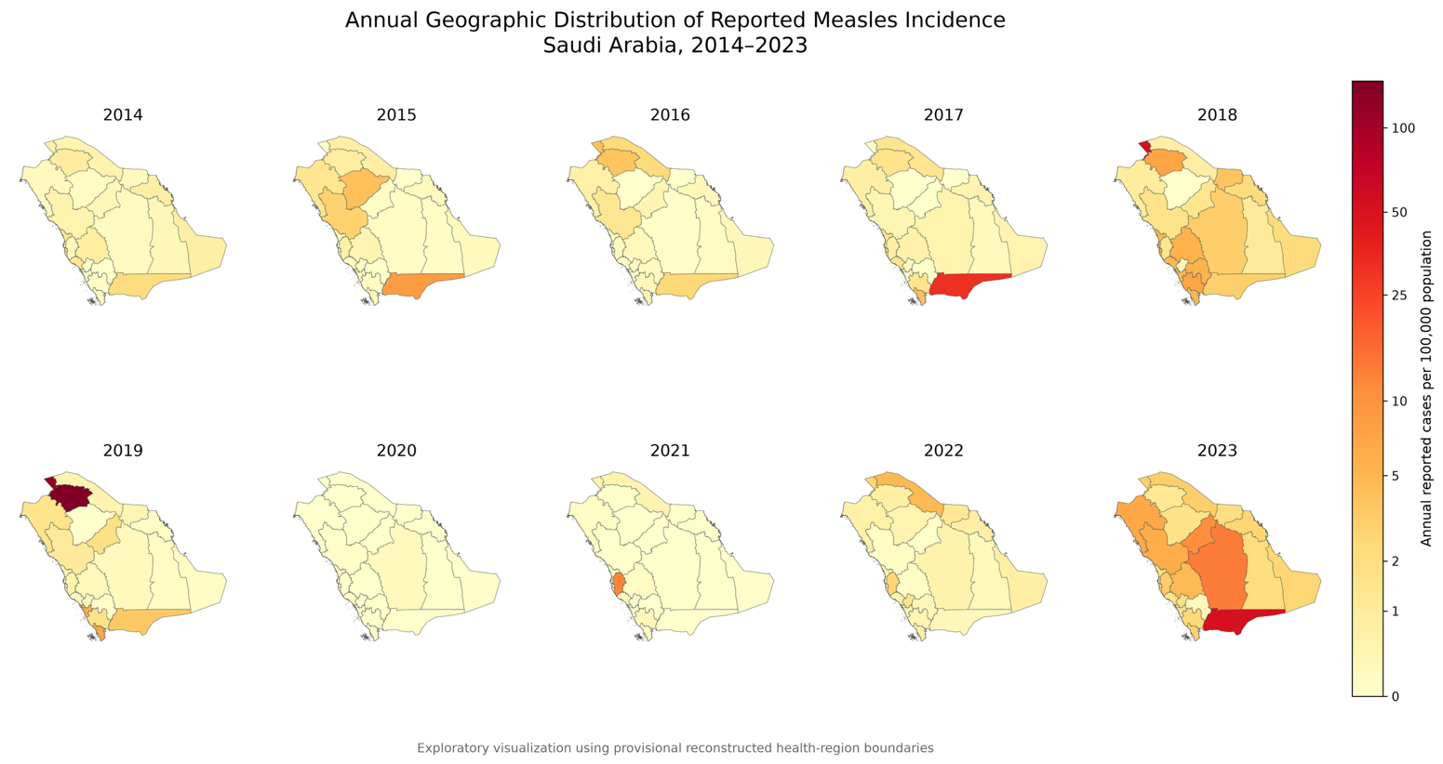
  - Interactive annual geographic incident map
An interactive geographic visualization was developed to facilitate exploration of annual measles incidence across the 20 Saudi health regions during 2014–2023. The visualization incorporates a year-selection slider and animation controls, allowing users to examine changes in regional incidence over time. Hover information displays the health-region name, annual reported case count, and incidence rate per 100,000 population. A consistent logarithmically transformed color scale was maintained across all years to support direct comparison of incidence magnitudes.
Click here to view the interactive map

- Geographic Distribution of Observed-to-Expected Ratios
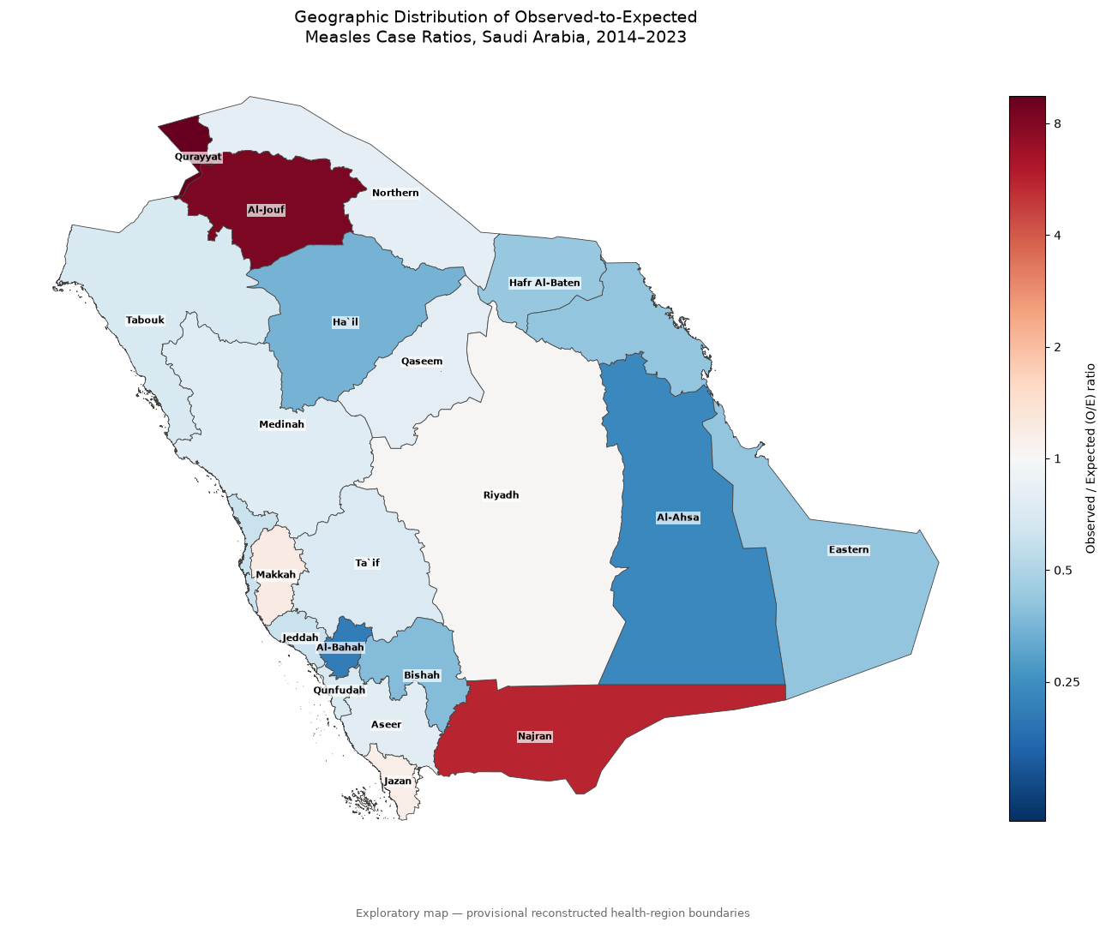\

- Geographic Classification of O/E Deviations
We additionally classified each health region according to whether its observed-to-expected (O/E) measles case ratio fell above, within, or below the simultaneous 95% multinomial null reference envelope. This categorical geographic visualization complements the continuous O/E map by emphasizing which regions deviated from the population-proportional null expectation over 2014–2023. Four regions (Al-Jouf, Qurayyat, Najran, and Makkah) were above the null reference range, four regions (Jazan, Northern, Qunfudah, and Riyadh) were within the reference range, and the remaining 12 regions were below it.

Health region | Observed Cases | Expected Cases | O/E Ratio | Simultaneous 95% Null Lower | Simultaneous 95% Null Upper | Classification
Qurayyat | 317 | 33,36495 | 9,500987 | 0,476706 | 1,523294 | Higher than null reference
Al-Jouf | 567 | 67,63051 | 8,383791 | 0,633515 | 1,366485 | Higher than null reference
Najran | 603 | 108,6266 | 5,551127 | 0,711815 | 1,288185 | Higher than null reference
Makkah | 545 | 456,7219 | 1,193286 | 0,863708 | 1,136292 | Higher than null reference
Jazan | 322 | 277,7456 | 1,159334 | 0,822392 | 1,177608 | Within null reference
Riyadh | 1600 | 1550,511 | 1,031918 | 0,933724 | 1,066276 | Within null reference
Northern | 55 | 68,46475 | 0,803333 | 0,635765 | 1,364235 | Within null reference
Qaseem | 204 | 256,6539 | 0,794845 | 0,814889 | 1,185111 | Lower than null reference
Aseer | 253 | 328,8662 | 0,76931 | 0,837503 | 1,162497 | Lower than null reference
Medinah | 300 | 395,1696 | 0,759168 | 0,852628 | 1,147372 | Lower than null reference
Ta`if | 160 | 225,4204 | 0,709785 | 0,801964 | 1,198036 | Lower than null reference
Qunfudah | 38 | 54,343 | 0,699262 | 0,590689 | 1,409311 | Within null reference
Tabouk | 116 | 166,649 | 0,696074 | 0,76848 | 1,23152 | Lower than null reference
Jeddah | 489 | 805,6269 | 0,606981 | 0,900676 | 1,099324 | Lower than null reference
Hafr Al-Baten | 36 | 84,39708 | 0,426555 | 0,672383 | 1,327617 | Lower than null reference
Eastern | 254 | 622,8733 | 0,407788 | 0,885046 | 1,114954 | Lower than null reference
Bishah | 25 | 65,90997 | 0,379305 | 0,628715 | 1,371285 | Lower than null reference
Ha`il | 46 | 133,1055 | 0,345591 | 0,740205 | 1,259795 | Lower than null reference
Al-Ahsa | 51 | 217,4263 | 0,234562 | 0,798202 | 1,201798 | Lower than null reference
Al-Bahah | 16 | 77,49369 | 0,206468 | 0,657955 | 1,342045 | Lower than null reference

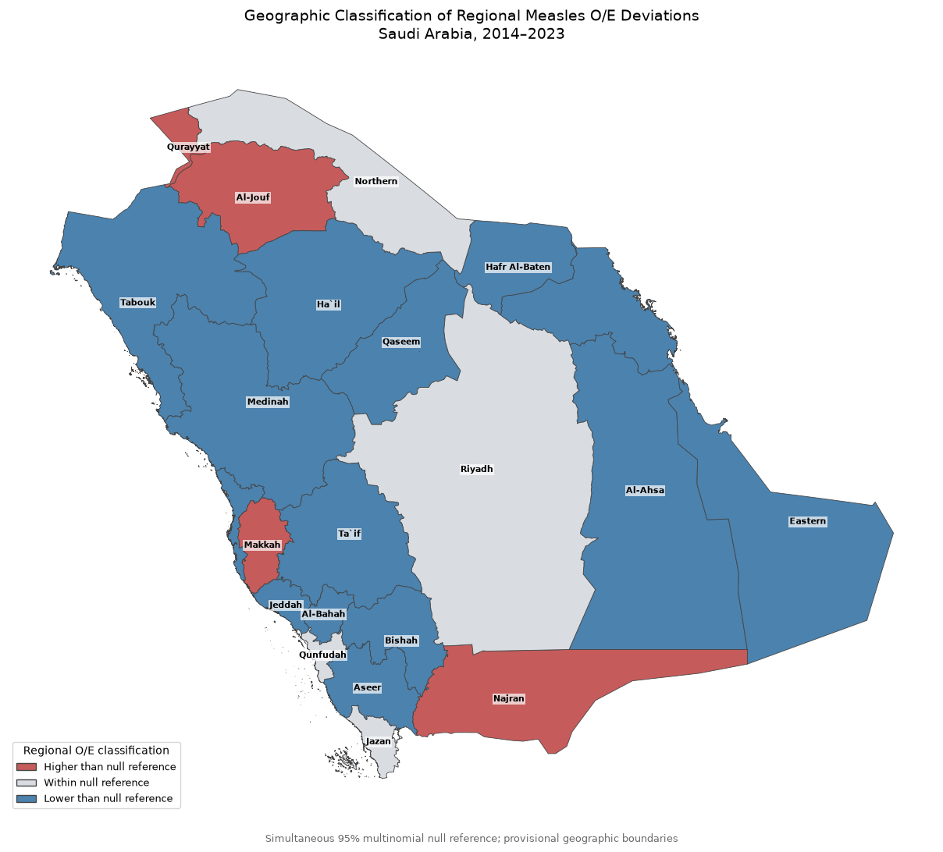

- National Age-Group Distribution

Annual Count
Year | <1 year | 1–4 years | 5–14 years | 15–44 years | 45+ years
2014 | 33 | 55 | 26 | 35 | 5
2015 | 65 | 73 | 21 | 55 | 5
2016 | 33 | 43 | 16 | 28 | 5
2017 | 164 | 132 | 58 | 90 | 13
2018 | 356 | 436 | 188 | 170 | 6
2019 | 403 | 391 | 122 | 97 | 11
2020 | 4 | 14 | 12 | 4 | 0
2021 | 94 | 120 | 25 | 86 | 2
2022 | 49 | 88 | 40 | 68 | 2
2023 | 561 | 916 | 565 | 185 | 27

Annual Percentage
Year | <1 year | 1–4 years | 5–14 years | 15–44 years | 45+ years
2014 | 21,4286 | 35,7143 | 16,8831 | 22,7273 | 3,2468
2015 | 29,6804 | 33,3333 | 9,589 | 25,1142 | 2,2831
2016 | 26,4 | 34,4 | 12,8 | 22,4 | 4
2017 | 35,8862 | 28,884 | 12,6915 | 19,6937 | 2,8446
2018 | 30,7958 | 37,7163 | 16,263 | 14,7059 | 0,519
2019 | 39,3555 | 38,1836 | 11,9141 | 9,4727 | 1,0742
2020 | 11,7647 | 41,1765 | 35,2941 | 11,7647 | 0
2021 | 28,7462 | 36,6972 | 7,6453 | 26,2997 | 0,6116
2022 | 19,8381 | 35,6275 | 16,1943 | 27,5304 | 0,8097
2023 | 24,8891 | 40,6389 | 25,0665 | 8,2076 | 1,1979

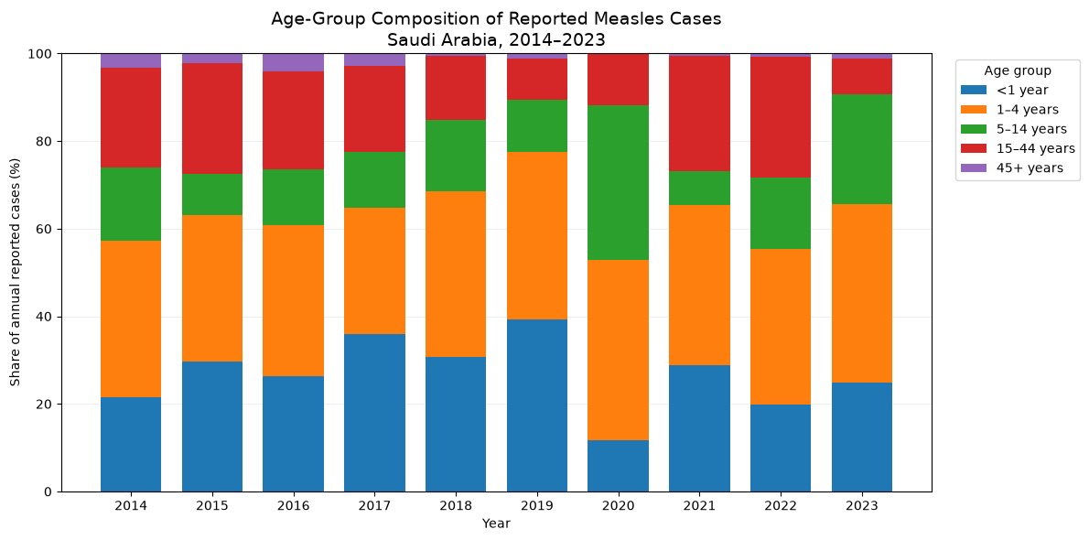

  - Annual Reported Measles Case by Age Group 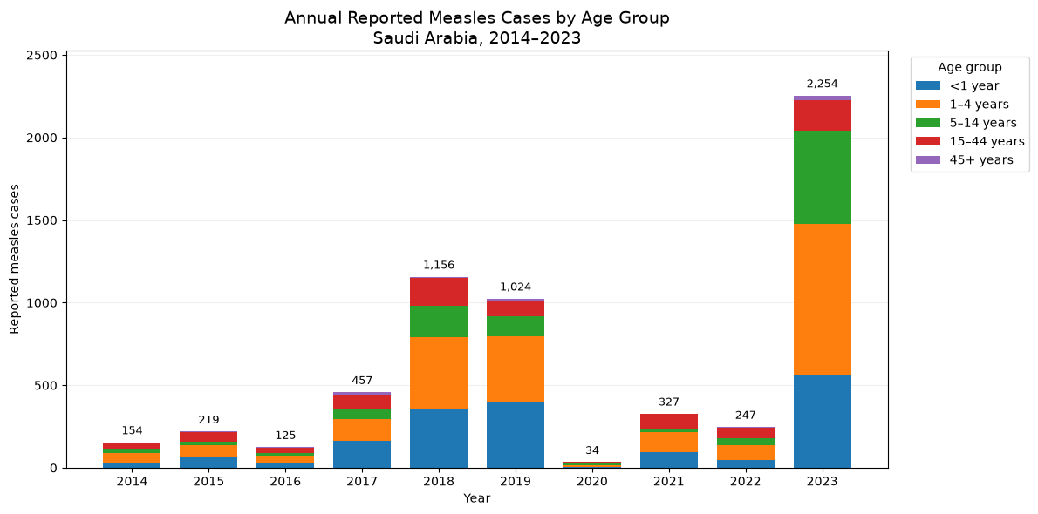
  - Age-Group Comparison of Major Measles Reporting Years

Age group | 2019 cases | 2023 cases | Case difference | Share of total difference (%)
<1 year | 403 | 561 | 158 | 12,85
1–4 years | 391 | 916 | 525 | 42,68
5–14 years | 122 | 565 | 443 | 36,02
15–44 years | 97 | 185 | 88 | 7,15
45+ years | 11 | 27 | 16 | 1,3
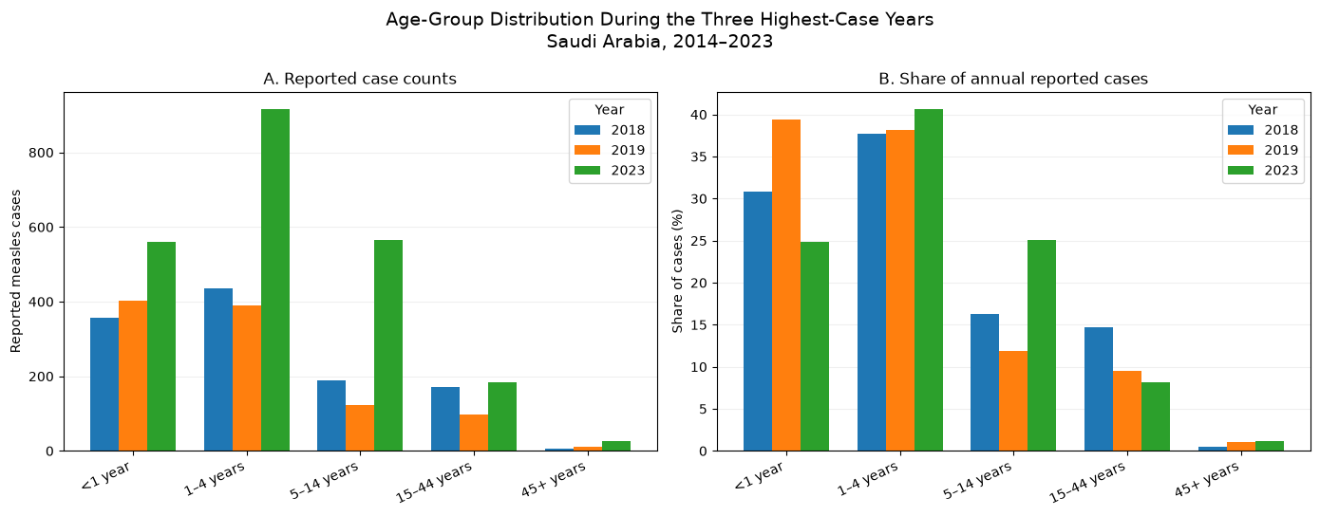

- National Monthly Distribution and Temporal Patterns of Reported Measles Cases

Monthly Counts
Year | Jan | Feb | Mar | Apr | May | Jun | Jul | Aug | Sep | Oct | Nov | Dec
2014 | 17 | 20 | 17 | 18 | 16 | 10 | 4 | 7 | 5 | 13 | 13 | 14
2015 | 20 | 6 | 4 | 38 | 54 | 51 | 17 | 15 | 5 | 5 | 4 | 0
2016 | 4 | 9 | 8 | 4 | 7 | 6 | 19 | 23 | 6 | 12 | 9 | 18
2017 | 82 | 84 | 39 | 26 | 17 | 8 | 17 | 13 | 28 | 27 | 53 | 63
2018 | 73 | 105 | 185 | 251 | 169 | 73 | 69 | 34 | 39 | 52 | 51 | 55
2019 | 292 | 424 | 157 | 62 | 19 | 26 | 14 | 13 | 1 | 3 | 12 | 1
2020 | 5 | 8 | 12 | 7 | 1 | 0 | 0 | 0 | 0 | 0 | 0 | 1
2021 | 0 | 1 | 2 | 0 | 3 | 3 | 1 | 1 | 67 | 123 | 96 | 30
2022 | 18 | 3 | 6 | 1 | 10 | 33 | 15 | 39 | 40 | 20 | 27 | 35
2023 | 110 | 161 | 400 | 351 | 372 | 243 | 191 | 152 | 96 | 71 | 47 | 60
Monthly Percentages
Year | Jan | Feb | Mar | Apr | May | Jun | Jul | Aug | Sep | Oct | Nov | Dec
2014 | 11,039 | 12,987 | 11,039 | 11,6883 | 10,3896 | 6,4935 | 2,5974 | 4,5455 | 3,2468 | 8,4416 | 8,4416 | 9,0909
2015 | 9,1324 | 2,7397 | 1,8265 | 17,3516 | 24,6575 | 23,2877 | 7,7626 | 6,8493 | 2,2831 | 2,2831 | 1,8265 | 0
2016 | 3,2 | 7,2 | 6,4 | 3,2 | 5,6 | 4,8 | 15,2 | 18,4 | 4,8 | 9,6 | 7,2 | 14,4
2017 | 17,9431 | 18,3807 | 8,5339 | 5,6893 | 3,7199 | 1,7505 | 3,7199 | 2,8446 | 6,1269 | 5,9081 | 11,5974 | 13,7856
2018 | 6,3149 | 9,083 | 16,0035 | 21,7128 | 14,6194 | 6,3149 | 5,9689 | 2,9412 | 3,3737 | 4,4983 | 4,4118 | 4,7578
2019 | 28,5156 | 41,4062 | 15,332 | 6,0547 | 1,8555 | 2,5391 | 1,3672 | 1,2695 | 0,0977 | 0,293 | 1,1719 | 0,0977
2020 | 14,7059 | 23,5294 | 35,2941 | 20,5882 | 2,9412 | 0 | 0 | 0 | 0 | 0 | 0 | 2,9412
2021 | 0 | 0,3058 | 0,6116 | 0 | 0,9174 | 0,9174 | 0,3058 | 0,3058 | 20,4893 | 37,6147 | 29,3578 | 9,1743
2022 | 7,2874 | 1,2146 | 2,4291 | 0,4049 | 4,0486 | 13,3603 | 6,0729 | 15,7895 | 16,1943 | 8,0972 | 10,9312 | 14,17
2023 | 4,8802 | 7,1429 | 17,7462 | 15,5723 | 16,504 | 10,7808 | 8,4738 | 6,7436 | 4,2591 | 3,15 | 2,0852 | 2,6619

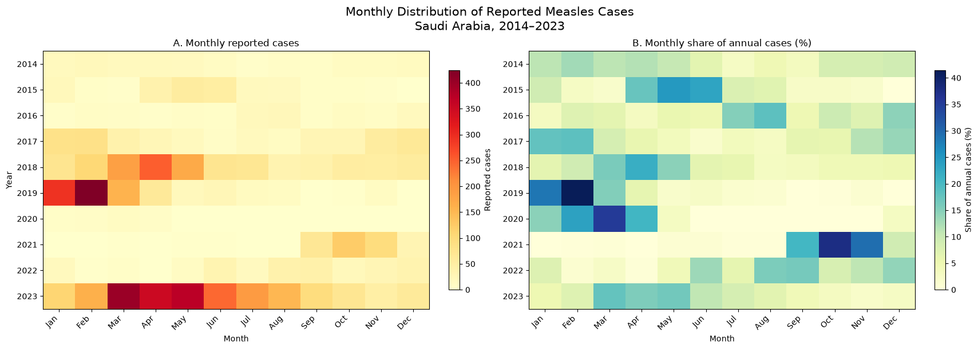

  - Monthly Distribution of Reported Measles Cases

Year | Annual cases | Peak month | Peak month cases | Peak month share (%) | Peak  3-month period | Peak  3-month cases | Peak  3-month share (%)
2014 | 154 | Feb | 20 | 12,99 | Feb–Apr | 55 | 35,71
2015 | 219 | May | 54 | 24,66 | Apr–Jun | 143 | 65,3
2016 | 125 | Aug | 23 | 18,4 | Jun–Aug | 48 | 38,4
2017 | 457 | Feb | 84 | 18,38 | Jan–Mar | 205 | 44,86
2018 | 1156 | Apr | 251 | 21,71 | Mar–May | 605 | 52,34
2019 | 1024 | Feb | 424 | 41,41 | Jan–Mar | 873 | 85,25
2020 | 34 | Mar | 12 | 35,29 | Feb–Apr | 27 | 79,41
2021 | 327 | Oct | 123 | 37,61 | Sep–Nov | 286 | 87,46
2022 | 247 | Sep | 40 | 16,19 | Aug–Oct | 99 | 40,08
2023 | 2254 | Mar | 400 | 17,75 | Mar–May | 1123 | 49,82

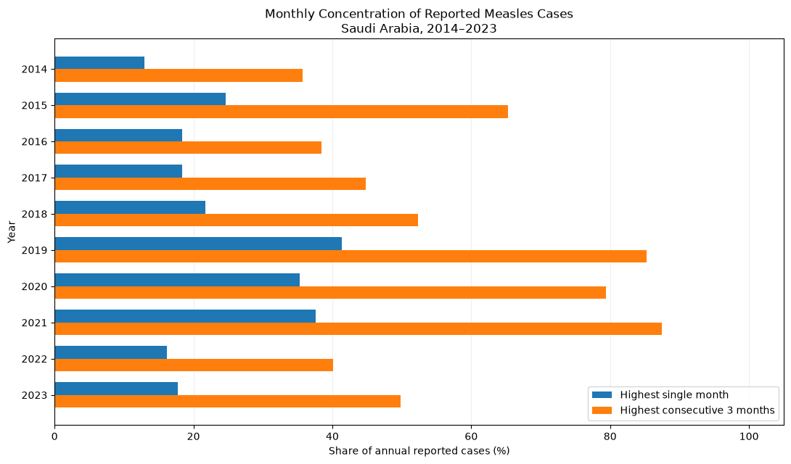

- Geographic Composition of Major Measles Reporting Years

Year | Riyadh | Jeddah | Aseer | Qurayyat | Jazan | Al-Jouf | Qaseem | Najran | Medinah | Eastern | Other regions
2018 | 23,5294 | 19,9827 | 11,2457 | 7,7855 | 6,9204 | 2,1626 | 1,7301 | 1,5571 | 2,9412 | 6,2284 | 15,917
2019 | 2,0508 | 1,6602 | 2,9297 | 20,2148 | 10,6445 | 49,8047 | 2,5391 | 2,0508 | 2,2461 | 0,3906 | 5,4688
2023 | 51,331 | 2,9725 | 1,8634 | 0,2662 | 1,7746 | 0,2218 | 6,3886 | 13,5315 | 5,8119 | 4,0816 | 11,7569

